A Revision Booklet for ICT, AIT and most computing courses
Peter J Faulks
Items highlighted in yellow are tasks for you to complete
Items in Blue italics are help tip
TABLE of CONTENTS
Health and safety 2
Employer regulations 2
Employer regulations 3
General working environment 3
Possible dangers and solutions 4
Glossary 5
Summary 6

Best of luck with your exams…



Health and safety
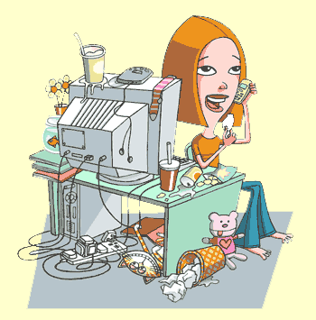
There are various health problems associated with the regular use of computers, and because of this employers must be aware of the regulations surrounding computer health and safety.
- Employer regulations
- General working environment
- Possible dangers and solutions
- Glossary

Employer regulations
The law states that an employer must:
- Provide tiltable screens
- Provide anti-glare screen filters
- Provide adjustable chairs
- Provide foot supports
- Make sure lighting is suitable
- Make sure workstations are not cramped
- Plan work at a computer so that there are frequent breaks
- Pay for appropriate eye and eyesight tests by an optician
Note: These regulations apply only to offices - not to students or pupils in schools or colleges.
In order to provide the satisfactory equipment for their employees, employers use ergonomics to assist the equipment design process. It is the science concerned with designing safe and comfortable machines for humans. This includes furniture design and the design of parts of the computer like keyboards.

Employer regulations
The law states that an employer must:
- Provide tiltable screens
- Provide anti-glare screen filters
- Provide adjustable chairs
- Provide foot supports
- Make sure lighting is suitable
- Make sure workstations are not cramped
- Plan work at a computer so that there are frequent breaks
- Pay for appropriate eye and eyesight tests by an optician
Note: These regulations apply only to offices - not to students or pupils in schools or colleges.
In order to provide the satisfactory equipment for their employees, employers use ergonomics to assist the equipment design process. It is the science concerned with designing safe and comfortable machines for humans. This includes furniture design and the design of parts of the computer like keyboards.

General working environment
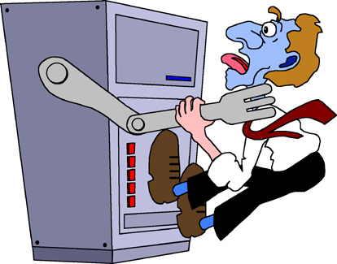
Don't forget that rules for all electrical appliances apply in a computer room. This means:
- There should be no trailing wires
- Food and drink should not be placed near a machine
- Electrical sockets must not be overloaded
- There must be adequate space around the machine
- Heating and ventilation must be suitable
- Lighting must be suitable with no glare or reflections
- Benches must be strong enough to support the computers.

Possible dangers and solutions
Within Information Technology it is important that people have an awareness of the various health and safety issues. Steps should also be taken towards preventing common problems rather than trying to cure them at a later date.
Back problems
Many computer users suffer serious back problems. This is probably due to a poor posture or an awkward position while sitting at a computer.
Solutions
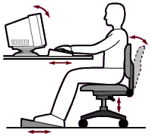
- A fully adjustable chair should avoid poor posture
- Footrests can reduce these problems
- Screens should tilt and turn to a position that avoids awkward movements

Repetitive Strain Injury (RSI)
Repetitive Strain Injury (RSI) is damage to the fingers, wrists and other parts of the body due to repeated movements over a long period of time.

Solution
- To prevent RSI, make sure your posture is correct, use wrist rests and have a five-minute break from typing every hour.
Eyestrain

Eyes can become strained after staring at a computer screen for a long time, particularly if working in bad light, in glare or with a flickering screen.
Solutions
- Screen filters can remove a high percentage of the harmful rays emitted from a computer screen
- Use screens that do not flicker
- Take regular breaks - do not work for more than one hour without a break
- Lighting must be suitable and blinds fitted to windows to reduce glare
Ozone irritation
Health experts have suggested that ozone emitted from laser printers can lead to breathing problems.
Solution
- It is recommended that laser printers should be situated at least one metre away from where people are sitting and there should be good ventilation in the area.

Glossary
Ergonomics
Ergonomics is the science concerned with designing safe and comfortable machines for humans. This includes furniture design and the design of parts of the computer like keyboards.
Repetitive Strain Injury
RSI - damage to the fingers, wrists and other parts of the body due to repeated movements over a long period of time.

Summary
Topic | Information
the components of an information system | - Hardware: The term hardware refers to the physical parts of the computer  - Software: The software provides instructions for the computer  - Data: Data are facts that are used by program to produce useful information.  - Procedures: Procedures are the rules and guidelines that govern the operation of a computer system.  - People: the users or connectivity.
the main parts of a computer system | - Base/System unit  - Monitor/VDU  - Keyboard  - Mouse  - Processor (CPU) - The part of the computer that handles all processes and instructions supplied by memory unit (RAM)  - Memory (RAM) - Random Accessed Memory. The area of the computer that holds the instructions (processes) an information system gives it.  - Read Only Memory (ROM) - A chip or disk that holds information that cannot be changed.  - Disk drive - A mechanical device that you use to transfer information back and forth between the computer's memory and a disk.  - Hard disk - A large capacity storage area that offers access to store and retrieve information, very slow compare to RAM.
the main peripherals for a computer system | - Printer – provides a hard copy of information  - Scanner – allows you to scan data and input it into the PC  - Digital Camera – allows you to take digital photos and input them into the PC  - Monitor - A screen that displays the information in the computer.  - Keyboard - A device used to enter data and issue commands to the computer.
an operating system | - Operating System (OS) - software that acts as a link between the user and application software (programs), and hardware. (Windows XP , Mac OS, Linux )  - An operating system is the software which runs the computer. Its functions are:  Manage system resources; Communication between the hardware and software; Monitor performance; Operate utilities; Operate applications  - Examples Windows XP, Windows Vista, Mac OS X (Leopard)
application software and examples of how you can use each | - Application software (program) - Software that does specific tasks such as:  - Word processing software such as Word used for letters, reports …  - Presentation software such as Powerpoint used for presentations of school assignments, holiday highlights…  - Graphics software such as Paint or Photoshop used for image editing. For example to remove blemishes  - Authoring software such as Dreamweaver, Frontpage or Flash for the creation of websites  - Internet access software such as Internet Explorer or , Mozilla Firefox applications used to access the internet.  - E-mail software like Outlook used to manage Emails.  - Excel used for numerical data, graphs and spreadsheets. Create a personal budget.  - Database software used for creating databases such as address books  - Desktop Publishing used to create brochures, cards, calendars …
care for your computer | - Use Anti Virus software and ensure it is updated regularly  - Use Anti Spyware software to protect your computer from unauthorised downloaded programs  - Install a Firewall to protect your computer against hackers.  - Run Disk Cleanup regularly to delete unnecessary files  - Ensure your computer is dust free both inside and out to avoid the power supply, CPU and fans getting clogged  - Empty the recycle bin  - Change your password regularly
places in which you can buy a computer system for personal use. | - Retail department store with many departments including electronics  - On line shops such as eBay  - Specialist computer store  - 2nd hand out of newspaper
occupational safety and health considerations to do with computers. | - Workstation design ie., monitor Height, Chair Height, Elbow position  - Regular changing of position  - Refocussing eyes and looking in the distance  - Stretching  - Correct lighting  - RSI/Occupational overuse syndrome  - Neck problems  - No food or liquid near a computer
the Information Privacy Act and how it applies to you. | - Information privacy is about the rights of people and organisations to allow or not allow information about them to be used by others.  - It applies to students as they need to be aware of not giving out private details about themselves online.  - Students also have a right to expect their details they provide are secured and not abused when given out in a legitimate forum.
new developments in ICT for personal use. | - USB drive for TV – a flash drive that can carry TV programs and videos from the computer for playback on TV  - Virgin Mobile Broadband – broadband services provided to your mobile to compete with laptop
ways in which new ICT impacts on personal use | - Faster access to the internet  - More ways of accessing and using technology  - Sites such as You Tube and Face Book allow you to have your own space on the Internet  - New technologies provide better performance
ways in which ICT impacts on you personally | - Play games on the internet or computer  - Engage with virtual worlds on the internet  - Do research on the internet  - Communicate with friends easier i.e. chat  - Produce work for school  - Surf the net about personal favourite topics  - Create own sites, blogs, wikis

